Boundary Chapel meet for Bible study and Prayer fortnightly from March 3rd at 7:30pm. Contact Anne Brown for further information
Tel - 01538 755788.

Rudyard Methodist Church
Staffordshire Moorlands Circuit Fellowship Group @ Rudyard Methodist Church
Time for Tea, Coffee & Chat with Deacon Peter Ogle meeting at 1:30pm on the 2nd Tuesday of every month:
Tuesday 13th January
Tuesday 10th February
Tuesday 10th March
Tuesday 14th April
Tuesday 12th May
Tuesday 9th June
Tuesday 14th July
Tuesday 8th September
Tuesday 13th October
Tuesday 10th November
Tuesday 8th December
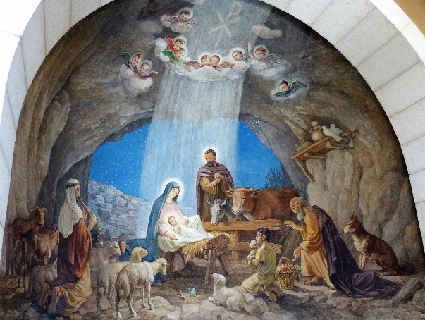Thank you for being such a lovely group of people, it has been a privilege to share the year with you. I hope you have a happy Christmas and God’s richest blessing for 2026.
Come and enjoy fellowship over a cuppa, with time to sing a well-loved hymn or two and a prayer. For more information email Peter at deaconpeter9@gmail.com. Everyone is very welcome – Hope to see you there.

Circuit Notices
In our attempt to cut down the amount of printing that local Churches need to do, We have removed the lists of ‘regular’ activities. Often people are passing by notices that appear week after week. For a time, we are going to advertise specific – nonrepeating activities/events. If you have dates, you would like publicising just let us know.

Ipstones Methodist Church

COFFEE, TOAST, CAKE & CHAT
Tuesday 6th and 20th January 2026
10.00 a.m. to 12 noon.
In the Schoolroom.

Mid-Week Communion
Wellspring Methodist Church, Cheadle -Mid-Week communion is held every other week at Wellspring Cheadle at 10:00am
Wednesday 24th December

Endon Methodist Church and St Lukes - This is on Wednesdays at 9.15-10:30am (After Refreshments)
17th Dec At St Luke’s
7th Jan at Endon Methodist
14th Jan St Luke’s
21st Jan Endon Methodist
28th Jan St Luke’s
The Gathering
Please note – From 7th December, The Gathering will meet at 15:00pm rather than 16:00pm.
Many Thanks




